- Introduction to Dynamic Routing Theory

Q1. List three differences between static routing and dynamic routing in a table format, using real-world analogies from apps like Google Maps or Swiggy to make each point relatable?

Answer
- Static routing is a method in which routes are manually configured by the network administrator, while dynamic routing automatically learns and updates routes.
Static Routing | Dynamic Routing
1. Manual Updates: Routes are manually configured and updated. | 1. Automatic Updates: Routes are automatically learned and updated using routing protocols.
2. No Automatic Path Change: If a route fails, it does not automatically switch to another path without additional configuration. | 2. Automatic Path Change: If a route fails, the routing protocol can find another available path.
3. Suitable for Small Networks: Static routing is easier to manage in small networks. | 3. Suitable for Large Networks: Dynamic routing is better for larger networks with frequent changes.

- Real-Life Examples:
- Google Maps: Static routing is like following a fixed route without checking traffic. Dynamic routing is like Google Maps suggesting another route when traffic or road closures occur.
- Swiggy: Static routing is like a delivery partner following a fixed delivery path. Dynamic routing is like automatically choosing another path when the original road is blocked.
- Uber: Static routing is suitable when the route never changes, while dynamic routing is like Uber updating the suggested route based on changing road conditions.
- Conclusion:
Static routing is useful for small and stable networks, while dynamic routing is better for networks where routes change frequently.

Q2. Open Cisco Packet Tracer and load a pre-configured network file with three routers using RIP. Use the 'show ip route' and 'show ip protocols' commands on each router to observe and write down the RIP-learned routes and their metrics?

Answer
- I opened a pre-configured RIP network in Cisco Packet Tracer containing three routers (Router6, Router7 and Router8).
- I used the show ip route command on each router to check the RIP-learned routes and their metrics. I also used the show ip protocols command to check the RIP version and routing update timers.
- Observed RIP Routes:
Router | RIP-Learned Networks | Metric
Router6 | 192.168.1.16/28, 192.168.1.64/28, 192.168.1.80/28 | 1 hop
Router7 | 192.168.1.32/28, 192.168.1.48/28, 192.168.1.80/28 | 1 hop
Router8 | 192.168.1.0/28, 192.168.1.48/28, 192.168.1.64/28 | 1 hop

- RIP Protocol Information:
- RIP Version: 1
- Administrative Distance: 120
- Update Timer: 30 seconds
- Invalid Timer: 180 seconds
- Hold-down Timer: 180 seconds
- Flush Timer: 240 seconds
- Result: All three routers successfully learned remote networks using RIP dynamic routing. The RIP-learned routes were marked with R in the routing table, and the observed metric was 1 hop.
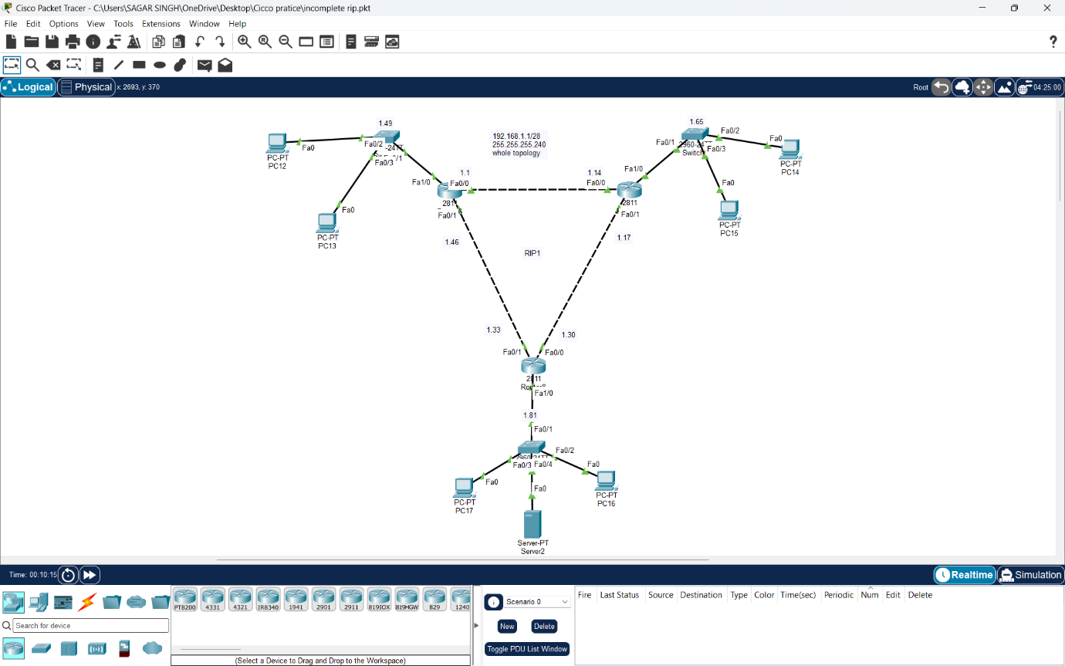
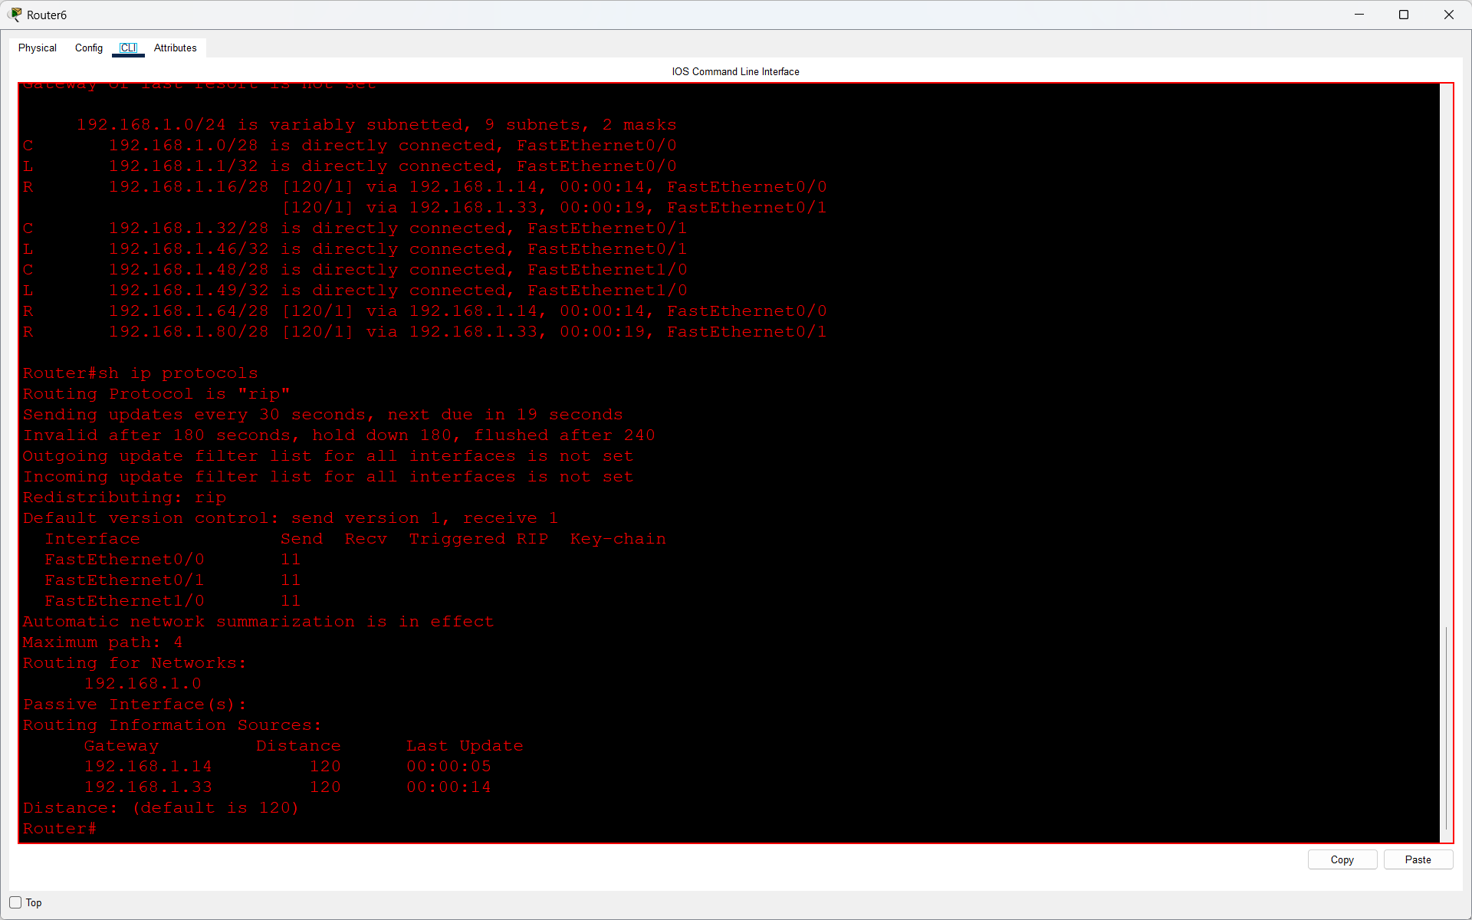
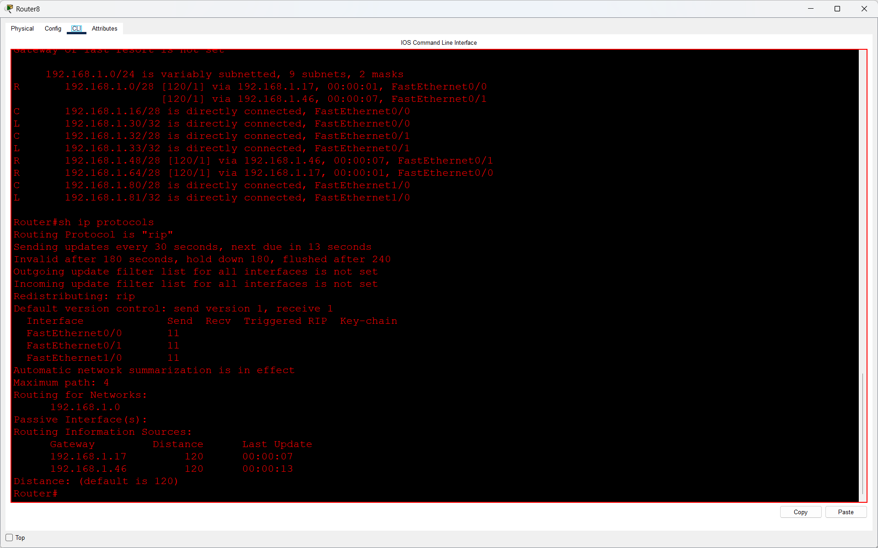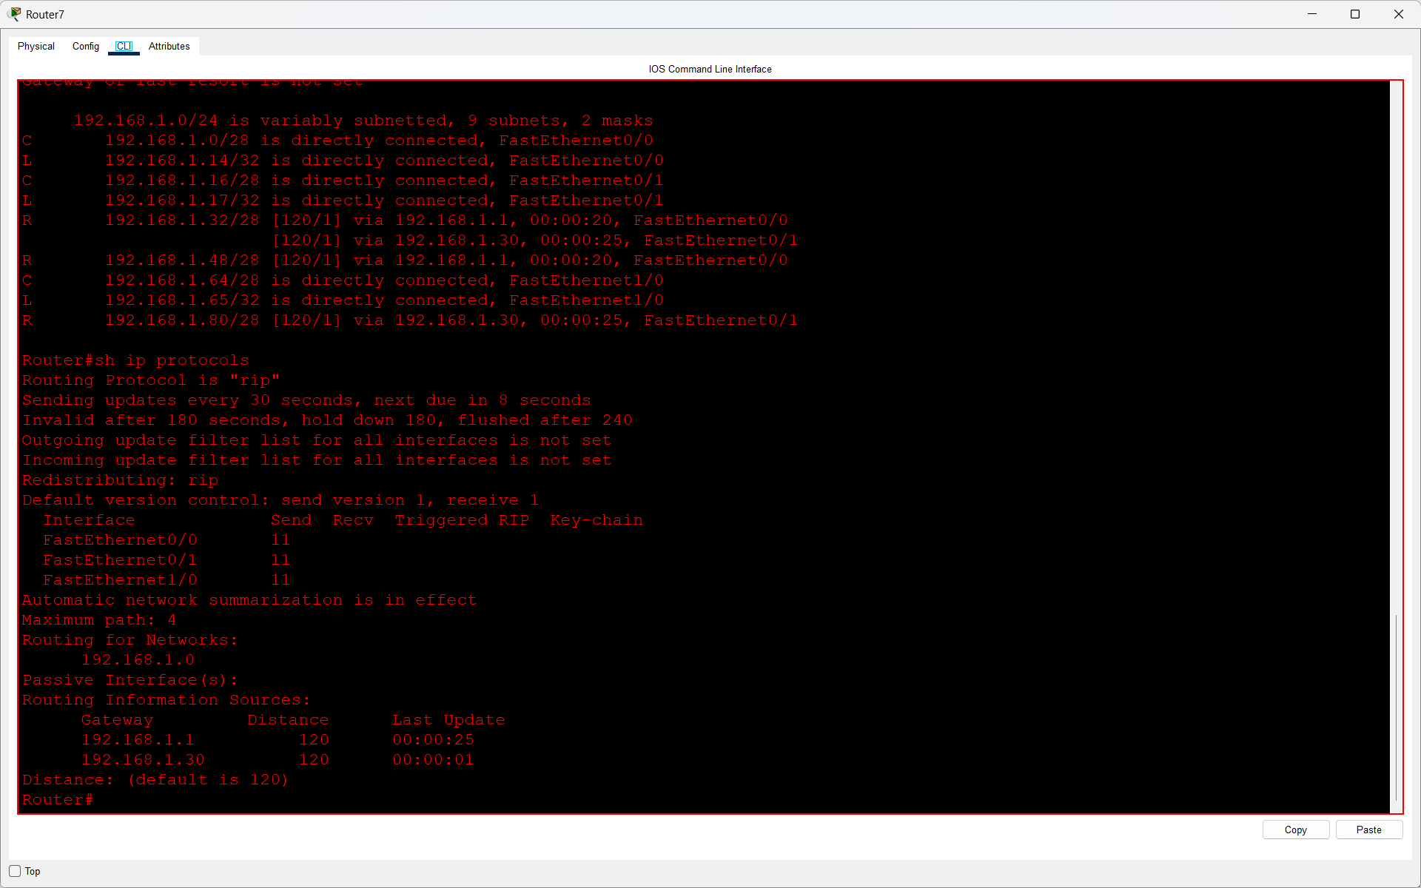

Q3. Simulate a network change by shutting down one interface on a router in the RIP-enabled topology. Observe and record how long it takes for the routing tables on the other routers to update and remove the unreachable route.<br><br><em><strong>Hint:</strong> Use the 'shutdown' command on an interface and monitor with 'show ip route' repeatedly.</em>?

Answer
- I opened my RIP network in Cisco Packet Tracer and checked the routing table using the show ip route command.
- Then I shut down the FastEthernet0/0 interface on Router8 using the shutdown command.
- After shutting down the interface, I repeatedly checked the routing table on Router6.
- Initially, the route 192.168.1.16/28 was marked as "possibly down." After RIP updated the routing table, the unreachable route was removed automatically.
- Observation:
- Routing Protocol: RIP Version 1
- RIP Update Interval: 30 seconds
- Invalid Timer: 180 seconds
- Flush Timer: 240 seconds
- Route Removed: 192.168.1.16/28
- Actual Time Taken: Not measured
- Result: RIP automatically removed the unreachable route from the routing table after the network connection failed.

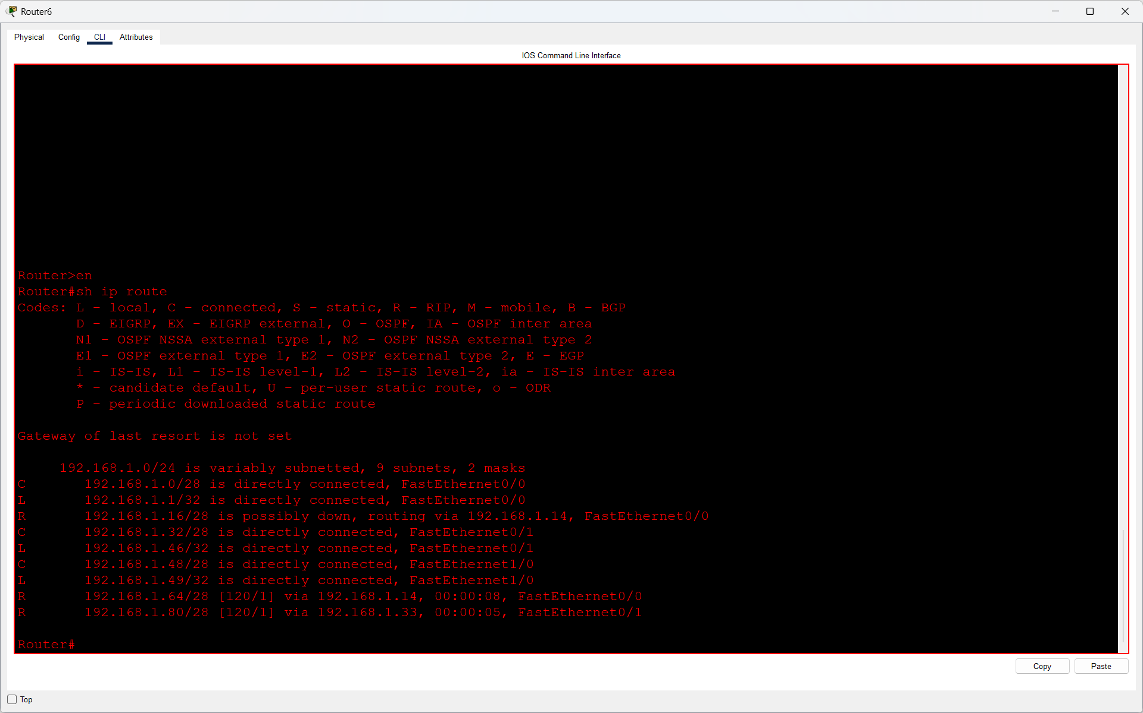

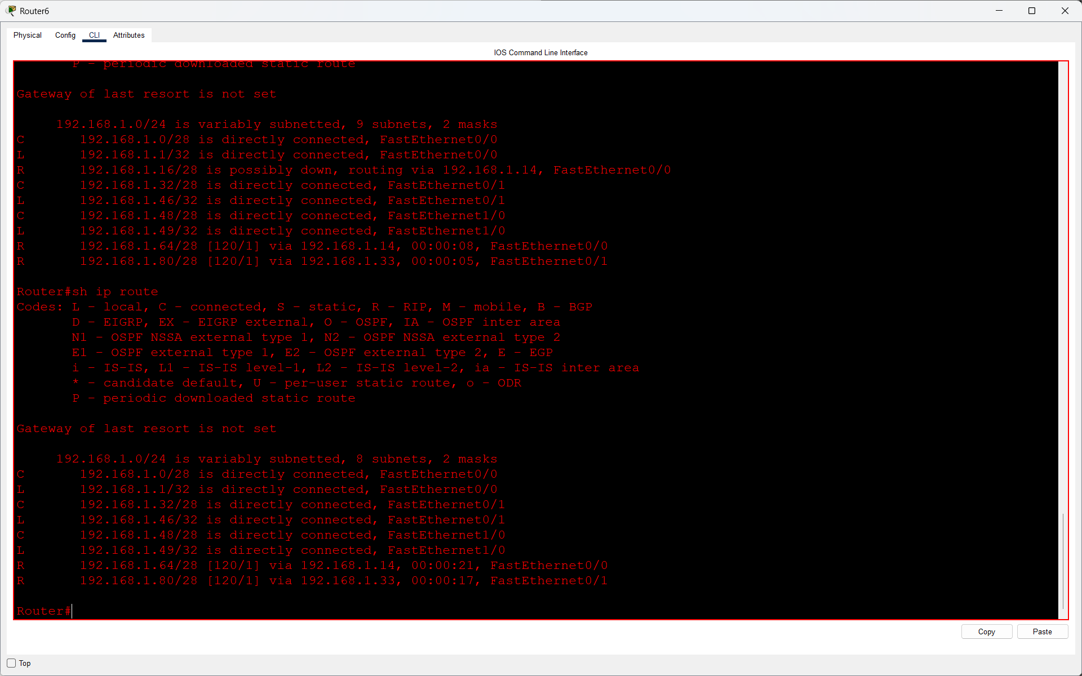

Q4. Explain in 3-4 sentences how dynamic routing in apps like Uber or Zomato delivery tracking is similar to RIP dynamic routing in networks. Focus on how routes or paths are updated automatically in both cases?

Answer
- Dynamic routing in RIP is similar to route updates in apps like Uber and Zomato.
- In RIP, routers automatically update their routing tables when network changes occur.
- Similarly, Uber and Zomato can update delivery routes when traffic or road conditions change.
- RIP selects routes based on hop count, while delivery apps choose routes based on factors like traffic, distance, and travel time.
- Both help find an alternative path when the current route becomes unavailable.

